**Project Design Phase-II**

**Technology Stack (Architecture & Stack)**

|  |  |
| --- | --- |
| Date | 15October 2022 |
| Team ID | PNT2022TMID49608 |
| Project Name | Project – Crude Oil Price Prediction |
| Maximum Marks | 4 Marks |

**Technical Architecture:**

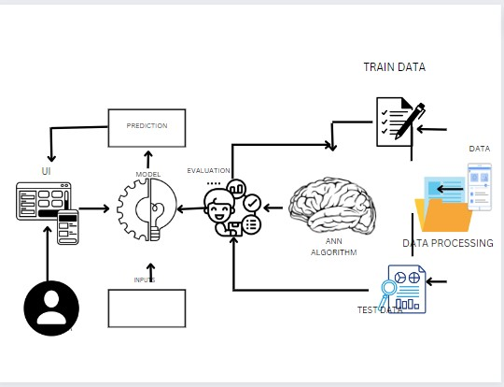

**Table-1 : Components & Technologies:**

|  |  |  |  |
| --- | --- | --- | --- |
| **S.No** | **Component** | **Description** | **Technology** |
|  | User Interface | User interacts with the User Interface | HTML, CSS, JavaScript / Python |
|  | Application Logic-1 | Import dataset | Python |
|  | Application Logic-2 | Data Pre-processing | Python |
|  | Application Logic-3 | Building regression model | Python |
|  | Deep learning model | Artificial Neural Network model | Price Predicting model |
|  | Infrastructure(Server / Cloud) | Application Deployment on Local System / Cloud Local Server Configuration : Apache  Cloud Server Configuration : IBM Cloud | Apache, IBM Cloud |

**Table-2: Application Characteristics:**

| **S.No** | **Characteristics** | **Description** | **Technology** |
| --- | --- | --- | --- |
|  | Open-Source Frameworks | Deep Learning Frameworks are – Tensor flow,Keras,Pytorch and Caffe | Python for AI |
|  | Availability | Distributed Server | Apache |
|  | Performance | It predicts the price of crude oil. | Python |